Wouter Wilmink en Ivar Post

**Plan van Aanpak M&N Bodyfashion**

Datum: 27/02/2019

Versie 1

Inhoudsopgave

Planning en Taakverdeling 3

Website Mockup 4

Home Pagina 4

Over Ons pagina 5

Merken Pagina 6

Klantspaarsysteem Pagina 7

Acties Pagina 9

Contact Pagina 10

Core CSS 11

# Planning en Taakverdeling

|  |  |  |  |
| --- | --- | --- | --- |
| Datum | Taak | Wie | Opmerkingen |
| 6-03-2019 | Core CSS (Documentatie) | Wouter | N/A |
| 6-03-2019 | Template maken (Documentatie) | Ivar | N/A |
| 13-03-2019 | Header (Site) | Beide | Git branch feature/header |
| 13-03-2019 | Navigatie (Site) | Ivar | Git branch feature/nav |
| 13-03-2019 | Footer (Site) | Wouter | Git branch feature/footer |
| 13-03-2019 | Responsiveness (Site) | Beide | N/A |
| 20-03-2019 | Home pagina (Site) | Beide | N/A |
| 20-03-2019 | Over Ons pagina (Site) | Ivar | N/A |
| 20-03-2019 | Merken pagina (Site) | Ivar | N/A |
| 20-03-2019 | Klantspaarsysteem pagina (Site) | Wouter | N/A |
| 20-03-2019 | Acties pagina (Site) | Wouter | N/A |
| 20-03-2019 | Contact pagina (Site) | Beide | N/A |
| 20-03-2019 | Responsiveness bijhouden (Site) | Beide | N/A |
| 27-03-2019 | Contactformulier (Site) | Beide | N/A |

# Website Mockup

## Home Pagina

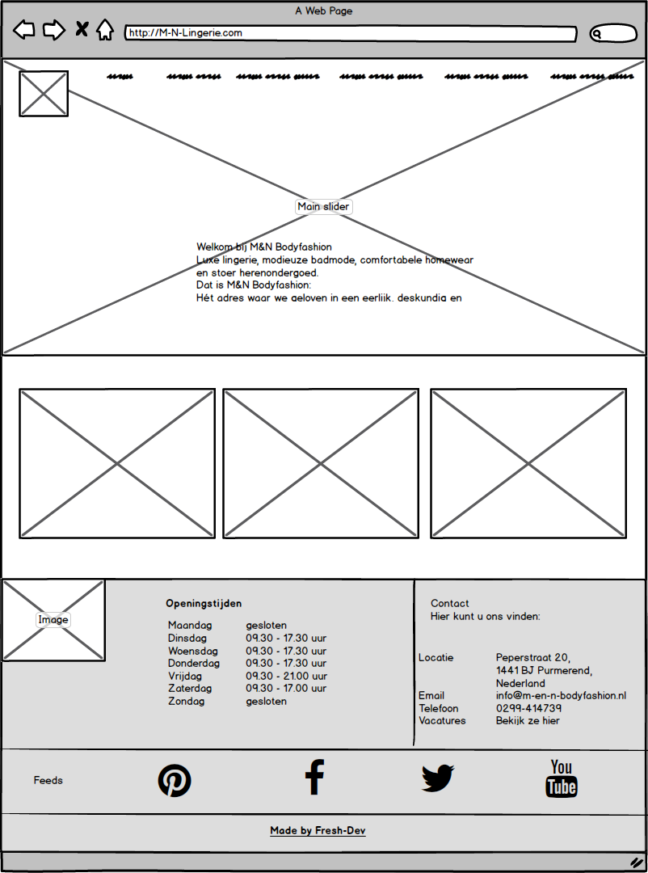

## Over Ons pagina

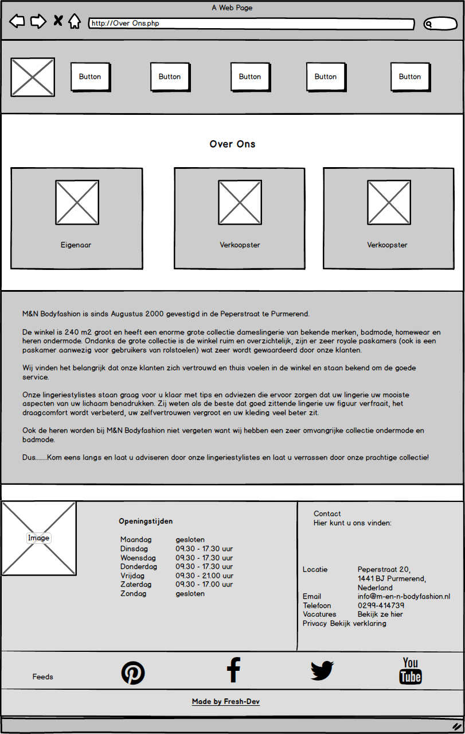

## Merken Pagina

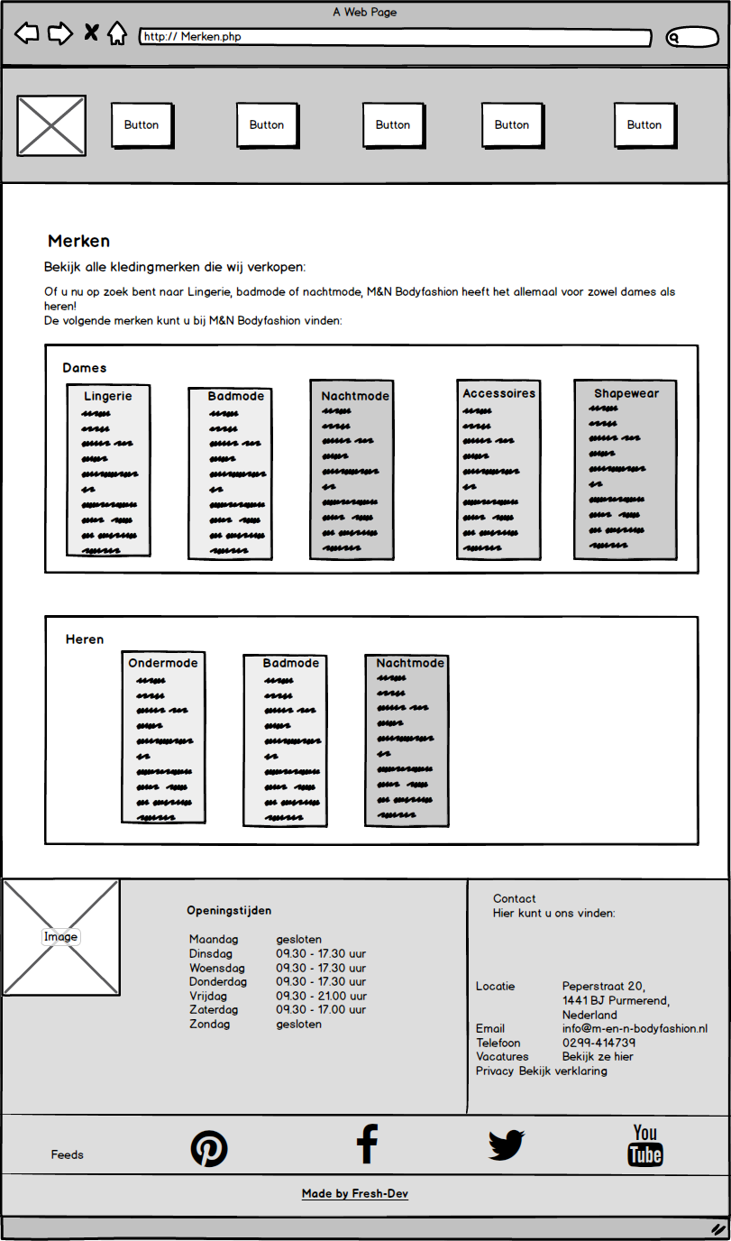

## Klantspaarsysteem Pagina

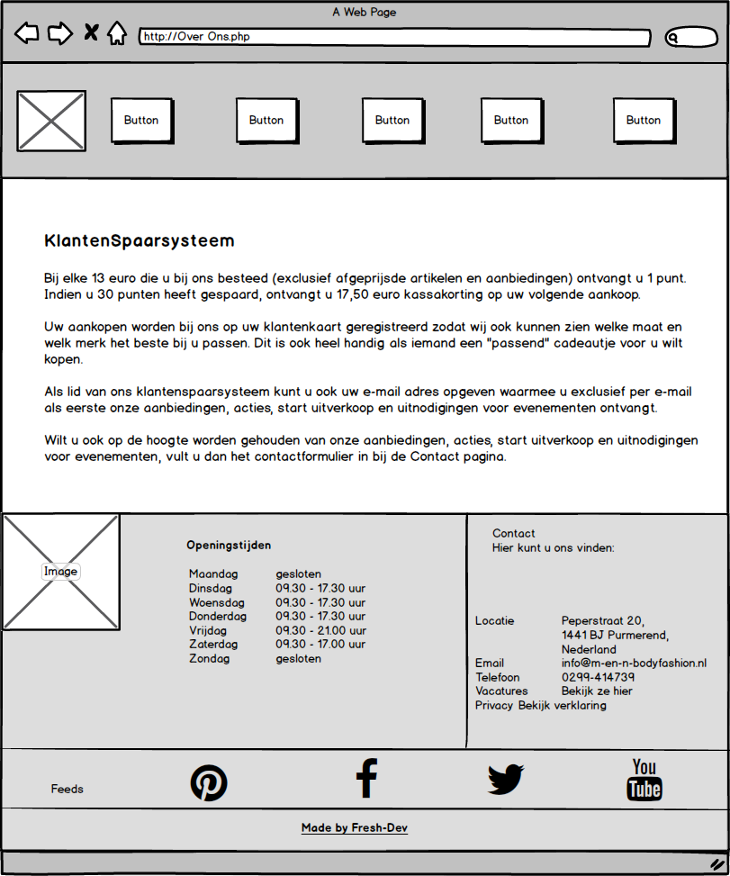

## Acties Pagina

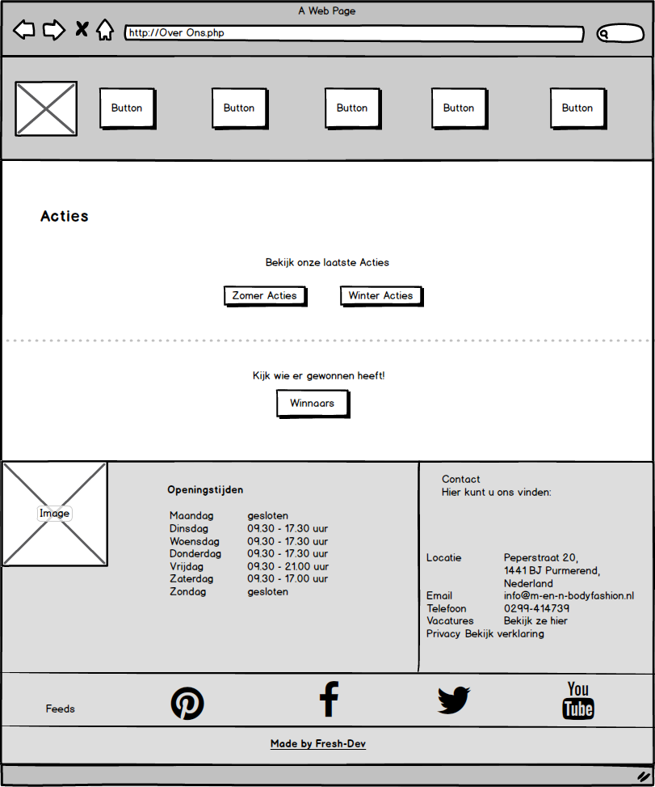

## Contact Pagina

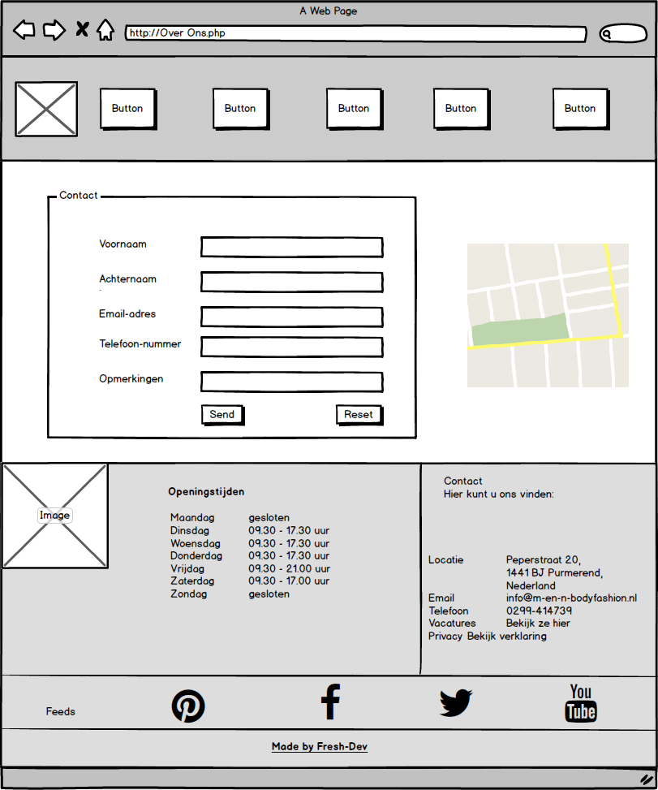

# Core CSS